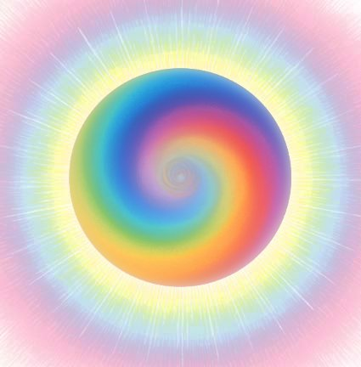

The Lilac Booklet no.7

The Lilac Booklet is linked to the crown chakra. This chakra is primarily focussed on the cosmic connection with the Generally All-encompassing in the Universe and feeds in a special manner all the other chakra’s with this universal life energy.

Enabling the individualisation possible of this process concrete is conducted by all the other chakra’s. All the chakra’s work together to make this process of development possible.

1. Introduction page 2

2. Opening the crown chakra (the goal thereof) page 3

3. Closing the crown and other chakra’s? page 4

4. Exercise for opening and closing page 4

5. Meditation in peace and in movement page 5

6. Meditations/exercises page 6

7. The healing influence of singing of
universal sounds page 16

8. Name-calling exercise, deeper meaning page 17

9. Different types of disasters page 25

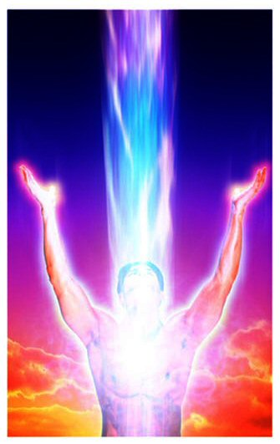
- Introduction

The Lilac Booklet focuses on the process of getting deeper into your own BEING, with trust and acceptance whilst being open to the Universal life power. In this manner it is possible to find, and to re-find, inner peace and to understand he processes that are present and active in the inner self.

Those who remain consciously with their inner selves at all times, and remains open to their own feelings and experiences, has a great lead on others with regard to survival and the maintenance of what is important in their inner most depths.

The cosmic connection of a person sees expression in the urge that the soul has to re-incarnate itself. This is an urge with the conscious desire for a destination on earth. This may however prove to be a difficult road to travel, often with traumatic experiences, yet it is a learning curve that needs to be accepted at the deeper inner level (this sometimes after protest). In essence the goal is to become Human in the deepest sense of the meaning, with solidarity and connection to the entire development of humanity, with which you are inextricably a part. This cosmic solidarity and connection takes place via the crown chakra. When you are consciously aware of this, and you feel responsible for your destination whilst opening yourself to the available help offered to you on human and cosmic levels, then you can face each moment as being an integral part of the greater learning experience.

In other words, everything that you leave behind in this world as a positive learning experience, feeds the collective field of the whole.

Try to consciously experience your learning experiences in a manner, which as much as possible, coincides at that moment with your current spiritual level or growth. Others may directly or indirectly benefit from this.

This Booklet mentions different exercises. People who choose to read The Lilac Booklet are often already formed by one or more courses dealing with healing, yoga, chakra’s, and energetic therapy, Reiki etc. These people may have their own exercises. Exercises that are known to them and that work well.

This Booklet does not propose to be complete. Its primary concern is to present a few possibilities for those that are interested and who feel it necessary due to the situation in which they are, to expand their contact with a higher consciousness, with the goal to increase the Universal life giving energy.

- Opening the crown chakra (the goal thereof)

Opening up the crown area and directing it in a pure manner to ask for, or dare to ask for, help from the non-physical guides, in so doing to feel and/or think via inspiration and to live further from the aspect of this inspiration. This is also an area that you know supersedes your own personal inspirations and wherein a greater field of guidance is active, whose desire it is to flow outwards in a supportive manner to the area in which a calamity has taken place where there are many souls present (the All-encompassing Guides, of the Godly).

Different religious beliefs have their own names for The Source of Life and Love. In the Christian West this is God, In the East Allah, Brahmann, Buddha, Ahura Mazda. Primitive peoples also have their own names for these deities. This Booklet has as its intention for the opening up to this Universal Energy by inviting, asking and praying for guidance from this Source.

The different names that are used in the different religions find their origin in different successive time periods, but are all directed at The One Source. When we are aware of this we can more easily understand and respect each other’s perceptions and beliefs in the expression of our godly beliefs, and in turn may also learn from each other. Supporting each other from premise of the knowledge of each, especially in times of need.

When the crown chakra is optimally opened, then the other chakra’s can be fed by this energy. Understandably to ensure a good flow of energy, all the chakra’s must be largely open.

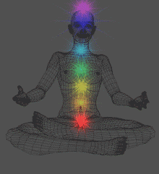

- Closing the crown and other chakra’s?

Must chakra’s always stand wide open?

It is important to realise and be conscious of the fact that chakra’s need not always be fully open. This would make us too vulnerable. Certainly in the event of calamities it is advisable that there are moments that we close them to attain peace within ourselves.

You will recognise when you have the need to do this. It may be that you feel over stimulated, and open to too many impressions. The more sensitive you are as a person, the sooner this will bother you. You will know this about yourself.

- Exercise for opening and closing

  - Opening: Direct you attention to your lowest chakra, your coccyx, and send your breath towards this spot.
When, as a result of your conscious breathing towards the spot, to begin to feel it, then imagine a beautiful flower with the colour of your choice that fits in with your chakra. A flower that is still in bud. Due to the light and the prana breath the flower buds slowly opens to reveal its beauty. Remain at that spot for a few moments before moving on to the next chakra. Continue this process with your 2nd chakra, the sacrum chakra, between the top of the pubic bone and the navel.
The 3rd chakra, the stomach chakra, also known as the solar plexus, is situated between the chest bone and navel (also known as the central heart chakra in some traditions).
The 4th chakra the heart chakra, is situated in the middle of the chest bone ( in some traditions known as the middle of 4 heartchacra’s).
The 5th Chakra, also known as the throat chakra, is situated in the middle of the throat area.
The 6th chakra, or the forehead chakra, is situated in the middle of the forehead.
The 7th chakra, or the crown chakra, is situated on the top of the head.

You may notice that the one chakra responds more easily than another, but with practice this can change.

  - Closing: Start at the top with the crown chakra and work in the opposite direction, downwards.
Once again, imagine a beautiful flower, this time open, and then the petals of the flower slowly close, just like some flowers do when they go to sleep at night.

The Lilac Booklet offers the opportunity to review by a process self-assessment and self-awareness to gain a clearer insight, this even when walking because you need to flee the area.

Review methods like: Meditative exercises that can progressively be executed whilst walking or dealing with issues. How to get to sleep or how to wake up etc.

Some issues have already been discussed in other chapters. The Yellow Booklet, for example, discusses how you lie down in trust or how you wake up and deal with a situation when panic hits (chapter 3;4;5).

- Meditation in peace and in movement

1st in rest and silence

2nd while moving when you need to alter position

Ad 1. When you concentrate your attention inwards, in silence, you gain the inspiration that you require at that moment, come into contact with your inner knowledge more easily.

Take time to do this. Haste may negatively influence the internal process. Continuously reacting to external stimuli, that touch you deeply, can be very tiring and disruptive. When external stimuli are guiding you to all directions you are like a driverless vehicle going to and from with a goal.

When you are in connection with your inner self, you are more open to signals from various levels within yourself:

- the physical

- the senses

- your feelings

- your intellect

- the relational, this referring to the interconnection between yourself, others and the world.

As a result integrated actions will lead to qualitatively more adequate behaviour, such as well-balanced and coordinated action.

Someone who knows how to centre himself well and to ground themselves with knowledge of what is taking place around them, like for example during meditation and silence, that person is better able to receive and pass on the healing influences in the air, to traumatised processes from the finely tuned non-physical world.

For example as a result of epidemics: The strengthened conscious connection with the soul offers more protection against contamination, but can of course not serve as a guarantee. (Refer to The Red Booklet no.1;5,7,8.)

An epidemic consists of live mechanisms that penetrate the human body. At a deeper level one can say that the body of a human being envelops his soul.
The soul, in turn, is in connection with a greater higher spiritual Being. One can view the body as a vehicle, that from its souls dedication, gains learning experiences on earth, so that the person can evolve spiritually and as a reincarnated earthly being, connected to the higher spiritual being to that which is All Knowing. When one accepts this view, then a person will deal with his/her body from a different perspective. The body is once again in contact with the physical reality and in so doing has durable learning experiences. Processes of illness are unavoidable, partly because the learning experiences can also take place via experiences that one has undergone. By undergoing experiences and learning from these, you have the possibility to act more consciously to matters that you are faced with in the future.

Ad2: Meditation is also possible where a peaceful moment is not possible.

- Focus your attention on your stomach, to the hara point. The hara point is situated 3 fingers breadth below your navel.

- Breathe towards this point in a relaxed, rhythmical manner, for example following the rhythm of your walking pattern.

- Remain focussing your attention into yourself, and also feel your heart.

- Simultaneously your attention is directed at your environment, but in a “detached” way, just like you are more an observer that a victim. In this way you make the best possible contact with your intuition, feel clear headed and think from your inner knowledge”. This inner knowledge is a quality of your soul, that you always carry with you, but that you can utilise or experience best when you open up your inner self to The All Knowing source of Love and Compassion. The Light from this source even shines in the dark and can give HOPE.

- Meditations/exercises

Meditations/exercises that are universally applicable to purify, heal and to promote grounding within yourself.

a. A simple Light exercise

b. Light source energy exercise

c. Drinking Light with your eyes

d. Gain a powerful aura with exercise

e. Letting energy flow, strengthens your aura

f. Consciously be aware of what ‘is’

g. Relaxation and purification of the energy system

h. Visualisation of flickering fluorescent ultra violet light

i. Exercise to be done before going to sleep

j. To attain total relaxation of thought

Exercises:

The most important aspect is that the immune system is in a good condition.
It may be badly undermined by stress and panic (as was mentioned earlier). Light power can be very helpful here. If you are able to retain and strengthen light power within yourself, this will increase your immunity.
Light power promotes the energy flow through your body.

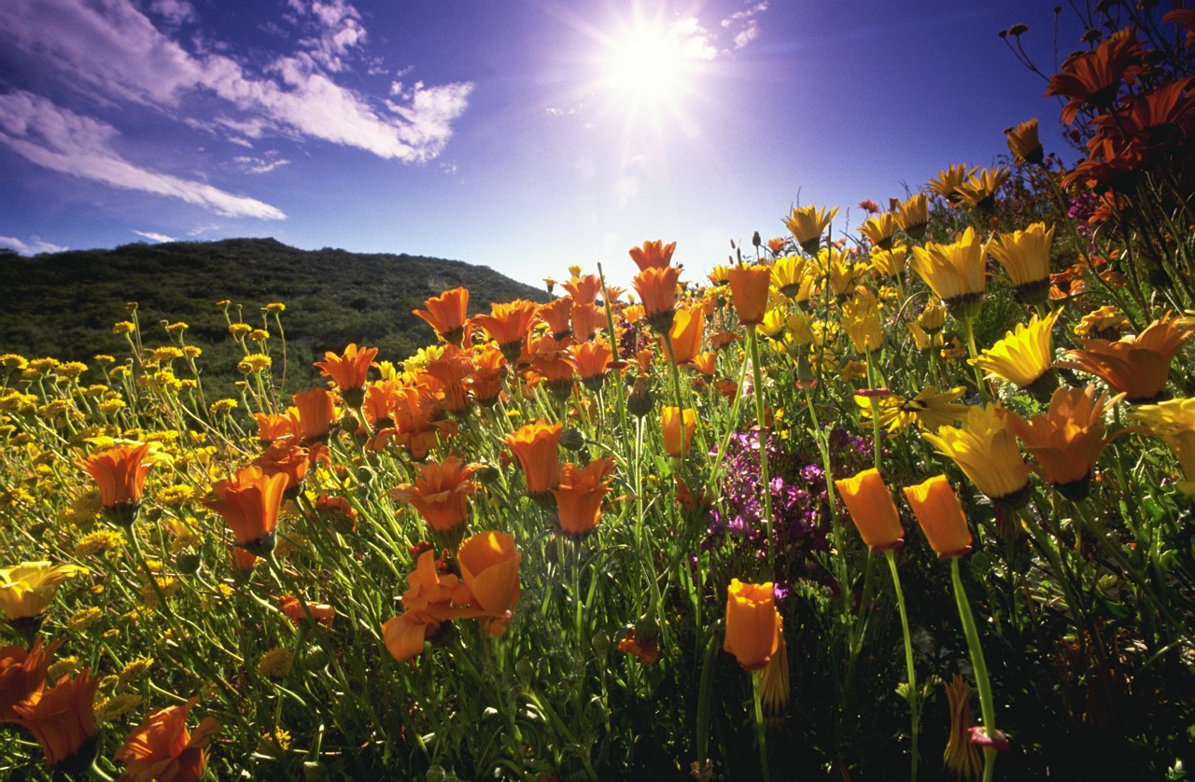

a. A simple Light exercise

You need to take time daily to bring your energy back up to its normal level. Where possible, spend a minimum of 20 minutes per day outside in natural light, even if the sun is not present or covered by cloud. Our body needs light and Prana (= life energy), that is available in excess in nature, see Booklet no.6;2).
A simple yoga exercise is like looking into a candle flame. By looking into the candle flame you allow light to enter via the eyes and flow to the pineal gland, that in turn sends the signals to the brain and all other energy centres. The pineal gland literally sucks up the light/energy, and hereafter supplies this new energy to all our other energy centres.

b. Light source energy exercise

- Visualise a light source emitting transparent, crystal clear light 50 cm above your crown.
- Imagine that you can open up your crown towards that light.
- Breath in the light from the light source and let this flow throughout you entire body, from the top to the bottom and into all the cells in the body.
- Next image that you are an x-ray man of woman walking through the body accurately observing what there is in the body; all the bones, tissues, blood vessels, muscles, nerves and lymph vessels.
- Let the light stream through all of these, lighting up the hollows and the spaces in the body like, for example the chest cavity.
- The light flow continues downwards and into the earth.
This exercise can provide relaxation and engineer a feeling of space.
When conscious breathing becomes problematic, then continue with the exercise in your imagination or in your thoughts.
This exercise can also be found in books dealing with yoga exercises, chakra healing etc.
It is also possible to conduct this exercise in the reverse direction (from the bottom to the top).

- Close your eyes and imagine that there is a radiant sun under your feet. The sun also shines up via the earth energy through our feet!

- Next, let the sun’s light shine up via your feet chakra’s and flow into your body until it reaches your crown, then out into the universe.

- This can be an extraordinary experience when the flow of energy flows down after entering at the crown, and when it flows upwards via your feet and they both meet in the heart area. What do you experience when this occurs?

A suggestion is to combine this exercise with the name calling exercise (refer for information to discussions further on in this Booklet and as mentioned in previous Booklets); this strengthens the experience of your inner core, the essence of your own being and individuality.

c. Drinking light with your eyes



- Seat or stand in such a manner that you can see the sky.
- Imagine that you are an empty crystal bowl.
- Look with open eyes outside the bowl towards the sky. Do not look into the sun, but to the surrounding world. Then slowly let your eyes wander over the different light variations that are present.
- See how the light is reflected in a thousand different ways in everything around you.
- Look at the quality of light that is reflected in the atmosphere.
- When you inhale you breathe in this light through your eyes. It is as if you are taking small sips of this light and you allow this light to fill the crystal bowl.
- When you do this, you will notice and be conscious of, your inner emotions. Very often positive feelings occur.
- When to bowl is full, close your eyes and taste the emotion.
- Do this exercise now and again for 30 seconds
- You can do this exercise in many different places.

This exercise will strengthen your emotional and mental acuity or consciousness. It will cleanse you deeply and generate seratonin. You will begin to notice differences between night and day (you can also apply this exercise under the light of the stars or the moon). You will also be more alert to changes in light at all moments of the day, the days and months throughout the year and the seasons. Each moment the light alters. This calls up different emotions. When you become more sensitive to this, then you are more deeply attuned to the cosmic rhythms: The language of the soul and the world. It deepens the information and communication about and with the cosmos. 30 seconds is not much for such an experience! This helps you to rise above all the misery of that moment.
(This is an exercise that can be recommended at all times, even when there are no stressful circumstances.)

d. Gain a powerful aura with exercise
Visualisation of a light-radiating aureole, a powerful aura surrounding your body.

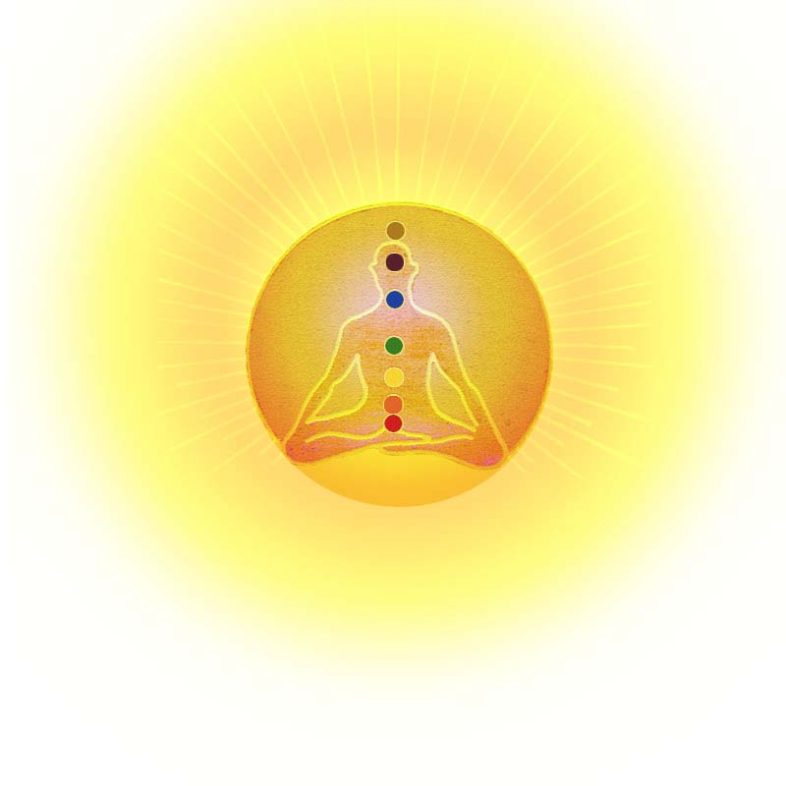
This exercise helps to supportively protect you against penetrating damaging viruses and bacteria (and other negative influences).

- Visualise, when meditating or in a different way, a radiating light that surrounds your whole body (thus, not only your head). This can be compared to an (radiating) aureole, as depicted by the old painters around holy effigies.

- Imagine that this energy field comes from within the body and radiates outwards. You may compare this to the most beautiful light that you can see emanating from a lamp, beautiful crystal clear light, or pale yellow and totally transparent. Similar to the form of an egg, or circle shaped spacious sphere around your body, without any clear borders, fading and radiating into the environment.

- When you feel that you need to protect yourself, then resonate internally within yourself the word “I” followed by your personal name. This is the name calling exercise mentioned later in this Booklet. The name calling exercise offers the best protection, because it guarantees your authenticity and thereby also maximises your survival mechanisms. When unexpected death occurs you will experience less influencing energies of despair, unrest and negatives influences from third parties. It engineers (promotes) in you a deeper spiritual awareness of your essence.

(Refer to the booklet “Dying in Catastrophes” published by STNL and the publishing company, De Vrije Mare, ISBN 978-90-813093-1-8)

- You can also imagine that you are inhaling light through your crown chakra, and that this light flows throughout your entire body, penetrating every cell, and when you exhale it flows into your aura, the energy layer surrounding your whole body, filling this with light.

e. Letting energy flow, strengthens your aura

- Inhale energy from the earth letting this earth-energy flow in through the foot chakra’s (centred in the middle of your feet) and upwards through your legs up to your 1st chakra situated in the coccyx, then flow out via your grounding back towards the earth

- Next. Let cosmic energy flow in through your crown and down your spine to the 1st chakra in your coccyx

- Then let the earth-energy in the 1st chakra mix with the cosmic energy, then letting this combined energy flow upwards along the front of the spine, back to your crown and out into your aura.

f. Consciously be aware of what “is”

Strengthening of the energy field by sending attention and breath to the hara-field

- The hara-field is the centre point in your body.

- When you are comfortable in this area, the other chakra’s attain greater balance and the aura field becomes more uniform and stronger in its equilibrium.

- Place your hands on your hara-field that is situated 3 fingers breadth below your navel.

- Breath towards this point and re-balance your energy field.

- Next focus your attention to the places in your body that are experiencing pain or are tense.

- Start with the spot that requires the most attention.

- Allow yourself to feel what there is. Not only will physical sensations reveal themselves, but possibly feelings, thoughts and images.

- Remain well grounded and undergo what comes up next. Try to look at this from a neutral position and observe it all. Do not judge, let it go. It is what it is.

- As a result the tensions may decrease.

- It is probable that when one spot softens up, another spot will identify itself also, in turn, seeking attention.

- Focus your attention on this spot.

- When conscious breathing is not a problem (as can be the case with hyperventilation), breathe in softly and gently over the painful and tense spots. You may also send light energy to these spots, if you wish making use of coloured light.

- Every colour that you chose intuitively for that specific spot is good, but end with white transparent light.

g. Relaxation and purification of the energy system

Relaxation and purification of the energy system by the stroking off with the hands, while being tuned in to the Source of Guidance.

1. Stroke off the whole body from top to bottom. Gently stroke with your hands over the skin, or if this feels unpleasant to the person that you are helping, then stroke with your hands just above the skin. This can be done over or above the clothes that the person is wearing.

2. Stroking off your own body or doing this exercise in pairs.

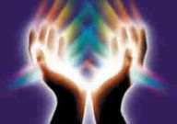

Ad1. Stroking off your own body

- Where possible, wash your hands.

- When performing the exercise while standing, stand with knees unlocked (loose).

- Ask for healing, purifying Light energy from your guides via your hands.

- Briefly hold the palms of your hands upwards when asking for help.

- Stroke downwards with both your hands from your crown.

- When doing this also stroke down your hair by taking them into your hands, as lots of negative energy sticks to hair.

- Stroke off, in turn, your face, back of the head, neck, shoulders, arms, trunk, both in front and the rear, your legs downwards to the ground.

- For added benefit stroke off downwards over your coccyx.

- Shake off your hands. Shake loose your arms. Relax yourself maximally while doing this.

- Repeat this three (3) times.

- Ensure that you carefully stroke off your legs both in front and the rear.

- Shake off your legs one by one, with loose feet so as to promote the muscles to relax.

- If you are able, seat yourself on your haunches.

- Hands on the ground in front of you

- Breath through your pelvic base and via all the body openings towards the ground sending, with your mind, all the waste materials into the ground.

- After such a cleansing exercise it can be very beneficial to refill yourself with the application of a light exercise, possibly with coloured light, or whatever else you need.

- Suggestion from the wisdom of shamanism: Purchase a bottle of Florida Blue Water as this is purifying and cheap and is obtainable in Chinese shops. This does however have a high percentage alcohol content and is not drinkable!! Place a small amount on your hands rubbing both palms together, and then perform the stroking off exercise.

Ad2. Stroking off each other, whilst being tuned in to the all-encompassing guidance

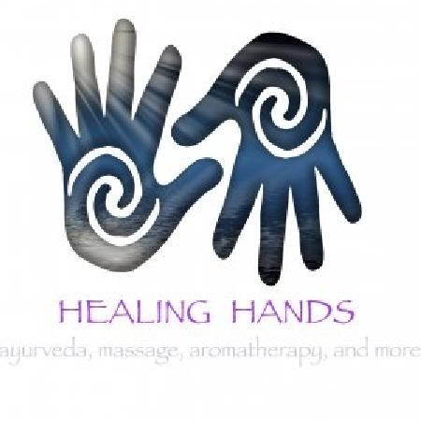

Ensure that there is a safe atmosphere.

One person lies down while the other known as the helper first places him- or herself at the feet and later at the head of the person lying down. You can keep on your clothes throughout this exercise.

- It is of course possible to do either, first lie down as the patient and thereafter then operate as the helper.

- The helper cleans himself, as person the abovementioned exercise: stroking off your own body.

- The person lying on the ground, the patient, needs to relax as much as possible and tunes into the highest possible pure Source of help, for example, God, Allah of the most pure light.

- The helper also tunes into the highest possible Source of help.

- The helper starts by holding the ankles of the patient in the cup of his hands.

- Remain in this position for a while.

- You can alternate by massaging the feet and the toes. Literally pull the tension out of the toes by pulling at them one by one.

- The helper then places himself at the patient’s head and holds the head in the cup of his hands with the fingertips on the base of the skull at the rear of the head.

- Both patient and helper should remain tuned into the help from the other dimension.

- Stroke off the other persons body 3 times from the top downwards.

- Do this gently. This may also be done by stroking just above the body of the other if this feels safer for that person.

- Give the other some time to remain lying down until it feels good to rise.

- Both parties should then drink a glass of water.

- Exchange role, the patient becomes the helper, and the helper the patient.

- The helper then washes his hands.

h. Visualisation of flickering fluorescent ultra violet light

Visualise flickering fluorescent ultraviolet light on the perimeter of your aura field to prevent radioactive radiation beaming into you
Total prevention of penetration of radioactive radiation from the body is not possible.
Visualisation of a flickering ultra violet light on the perimeter of your aura field restricts the penetration of radiation. When the visualisation keeps working, this can develop immunity in a natural way. The colour presented below works deeply relaxing and helps one to “uncramp” and promotes unity.
This is different to the blue that you visualise round your aura that has as its goal to show others the outer boundary of your aura. This is not what we need when we need to prevent radiation from entering. This is concerned with a very high vibrating violet like light with an extremely compact vibration, that you cannot avoid. This is a thick transparency. This is how strongly this needs to visualised.
Iodine (from nuclear radiation) is a light that penetrates in flashes and touches materials while pulsating splitting them open, and the ultra violet light has exactly the opposite effect.

These colours are collected from the computer, and are indicated hereafter:



The applicable colour is situated more towards the violet side of the spectrum: a very intense, strong fluorescent violet. The entire colour spectrum is built up from the chakra’s red, towards purple; then you get lilac colours, then silver and then gold. The colour that is indicated lies in the atmosphere where lilac/violet goes over into silver and becomes flickering and fluorescent.

i. Exercise to be done before going to sleep

Re-balancing before going to sleep

- Place your hands on your chest and send encouraging energies into your chest cavity till you feel that your whole chest is filled with breath.

- Next place your hands on your groins and radiate with energy until they start to feel warm, flowing into your legs and feet soles till these are open again. This allows you to prevent cramping up during a period wherein you are experiencing a lot.

- When you experience much psychological pain in your heart direct the stream of water from the shower, if it is possible to take a shower, onto your heart chakra (in the middle of the chest bone), so that your whole hart chakra is washed clean. This is very helpful when you do this every day. It has a comforting effect on you: you are definitely not dependent on any one else and you know that you can always rely on yourself during times of need or crisis.

- Thus you need to relax your heart every day by placing your hands over the heart area and sending in good energy, also beam this energy to your groin area and finally place your hands on your hara field before going to sleep, so that re-balancing takes place before you go to sleep.
(Refer to other exercises like, The Indigo Booklet no.6;5.)

j. To attain total relaxation of thought

- Relax your tongue

- Firstly, focus your attention to relax the area where your tongue is attached to your throat

- Visualise the tongue getting longer and longer while it remains in the mouth, then let the tongue gently sink deeper and deeper down onto the lower jaw.

- Even the lower jaw relaxes deeper and deeper until it becomes a fluffy bed in which the tongue is nestled.

- The tongue no longer touches the palate anywhere. The tongue is in complete rest.

- Next, relax your neck vertebrates and the spot where it is attached to the skull and the shoulders.

- Let this area become feather soft.

- Visualise an energy field of godly, friendly or ethereal hands that support you, so much so, that you allow these hands to support your neck and adjacent areas with their support that exists only for you. Allow this to happen and enjoy the luxury thereof. (Some people prefer to imagine the hands of angels’ and/of guides supporting them.)

- Now relax your spinal column so deeply that this also becomes downy and luxuriate your back with the energies attention and support given by the godly and/or ethereal healing hands.

- Finally: Warm your feet with your attention and luxuriate them in trust by placing them squarely on the ground/earth, or on your mattress.

7. The healing influence of singing of universal sounds

With calamities where a lot of stress, pain and sadness is present, music can have a stress reducing effect. In The Yellow Booklet no.3;8, the importance of music and song has already been mentioned. This is concerned with sounds that generate a subtle vibration, both in the body and towards the environment.

This has a neutralising and relaxing effect and makes connection.

This may be achieved with sounds, by singing, by playing of chords, miniature harp, didgeridoo or tempura. Instruments played meditatively such as the violin, subdued trumpet, wooden wind instruments, harmonicas, small harps, and so much more.
Music instruments offer words where there are no words as well as providing comfort and healing.

Sounds that work through into the chakra’s in a subtle manner are:

Oooooooooooo, Aaaaaaaaaaaaaaaaaa, Mmmmmmmmmmmmm (repetitive).

Each individual has his/her own affinity to sounds and instruments.

When a large calamity occurs bringing with it much suffering, people will, without thinking have a need to primarily scream, yell and of shouting out their emotions. Although this is understandable it offers no consolation or relief. It increases the consternation of each person and calls up a chain reaction of desolation.
To avoid this, rising emotions and despair need to be unloaded in another way to avoid these chain reactions. Tuning in to sound, song and instruments that lend expression and images of the suffering that is being experienced, allows people to recognise themselves in the experience with the aid of the sound chords. These sounds can eventually lead to acceptance and of obtaining peace with what has occurred. Try, where possible, to concentrate on the peace that the sounds can instil in you, and to bring about healing and support your conscience.

(Previously mentioned in The Yellow Booklet is that traumas need to flow downwards through the legs and feet and onwards into the ground.)

After the occurrence of a traumatic situation, song and stories may be used to tune in to the universal approach.
For children it is important that sounds can be heard at ear level, as the reception is better at this height.

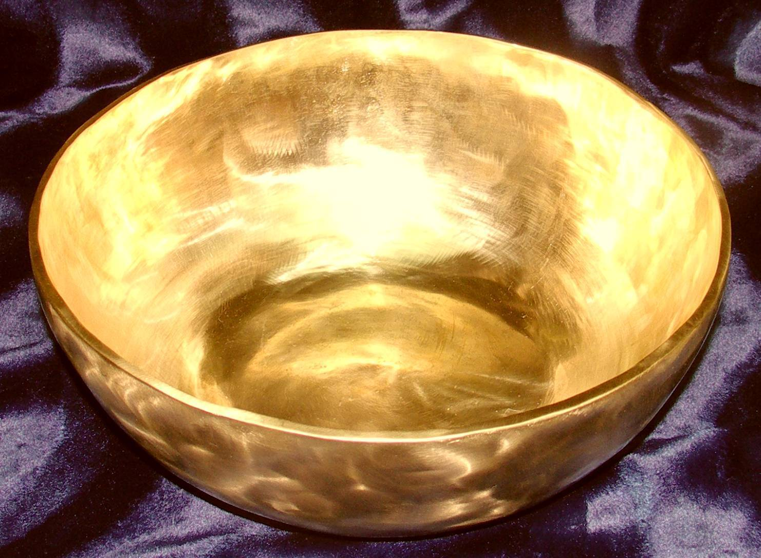

Sound is vibration

As such as a pebble in water
creating circles of movement

So the sound of a scale
sets us in motion

- Name-calling exercise, deeper meaning

Introduction:

This exercise is extremely important in the event of all serous traumatic events and the resulting disruption of the composition of the persons’ personality structure.

The name calling exercise helps you to, as far as possible, centre yourself within your own natural energy frequency, your own specific possibilities, whereby you become a reflection of your own nucleus (core self).

Why is this name calling exercise so powerful?

At birth you are given a name. Others give this to you, most often by your parents. Yet at a deeper level this is not without reason that you incarnated in a certain constellation (a confluence of factors that exerts influence on something or someone and as a consequence the result thereof), like those of your parents, possible brothers or sisters of the family. The name that your parents sought out for you has something to do with this constellation. Who the parents are, how they view matters, what historic background they hail from you will directly of indirectly be dealing (confronted) with. The given name will be inextricably part of you and you will often and for your life span on this earth, be addressed by this name.

This leaves behind impressions. These impressions that remain behind are often strongly influenced or coloured by the manner in which your name is spoken. Was it spoken lovingly, with gentleness, with cheerfulness or was it mainly correcting and chiding in nature? In any event one can conclude that a name very often gains and has a history. The name as thought out by your parents for that specific child, the name with which you in truth connects the soul with this incarnation, is often polluted by the colour variations of history. This may go back over an extended period of time including family history prior to your arrival. You may be named after a grandmother or grandfather, another family member, or for example a name very different from the names that previously appeared in your family history. A name thus has a history and this history is expanded upon each day with new experiences that you live through.

In your name is stored your life potential: Your original incarnation wish tat you now often cannot freely remember or feel. This is concerned with the challenge that made you come to learn lessons, to develop gifts and talents including the setting in which the learning programme is optimally has been invited during the course of this existence. Sometimes the optimal test, viewed from the perspective of all the difficulties that you meet along this life’s road, to eventually attain mastery, in spite of, or due to the most difficult circumstances you internally become a free person, well centred and adapted in your deepest inner self.

History will “reveal” itself the moment you introduce yourself with your name.
For example, in your work, you give a handshake, mention your name. You pick up the phone and identify yourself with your name. Often attached to your name there is an associated unconscious tension field. This may be attached to your first name and/or your surname with the result that you may not stand completely in the true meaning of your name. Than there is a certain amount of apprehension. When you do not completely live in your given name, because for whatever reason you have not totally identified with it, this can directly of indirectly create a situation whereby you cannot fully be present in your existence.

What does name-calling do?

This brings you back to your name as if you understand your name for the first time and, may also begin to live in your name for the first time. This can only be achieved by acceptance of the history. Thus accept everything that you opposed in your history such as, I would have preferred another mother or father, I do not like the family from which I originated, look at my history how I was teased at school, see how they take advantage of me. All this ballast is interwoven in your name.

So it is important that you re-code your name and in so doing try to take on the original intention of your carnation, on that spot, within the context of that setting and with all the learning processes and associated history.

Acquiescence and acceptance that is given under duress or against your will is not the same as acquiescence and acceptance from a free will. True acceptance is to accept what is, as it is without conditions attached.

The moment that we really accept our name and you are fused more closely to your body, a new energy field is immediately generated, namely that which you could potentially be. You are then linked to the primal information that is housed in your order to incarnate, in that place, in that setting and in this exercise process.

Then your potential can attain a process of re-creation.

What happens when you perform the name calling exercise?

The name calling exercise always begins by appointing the word “I”.

We all have an I, but are we allowed to be that I? How did our caregivers or minders (people who raised us) deal with our I?

The I is a natural individualistic mechanism. There is no incarnation that does not have the intention to form a healthy I. To develop an own uniqueness that is based upon your own real life experiences. In spiritual circles the I is often “suspected” as not being adequately directed at the spiritual world.

Only when there is evidence of a natural I-development, an experiential experience of your own life direction, then this possibly may give way to an inner transcendental existence.

The transcendental I is in contact, with the Essence, and with complete connection. This is also true for the finely tuned senses that are clearly aware and consciously experienced. The experiences that come to you are accepted. You, in truth, unlock the experiences by becoming consciously aware of them and to realise their influence on you, and then releasing them. You are then a channel through which all experiences flow, are lived through and are accordingly released.

The essence of the matter is that we do not have to be like one another, or that we need to continually fit in. You need to reinstate your name with honour, that you accept yourself as you are and the people that you meet with their pleasant or unpleasant characteristics, which you can also learn from.

Name-calling helps ensure that all experiences that threaten to, or have dragged you, out of your own essence, be rejected. This is also true for the projections that you have received during your life. This entails that people who regularly practice the name-calling exercise will clearly notice that they can let go of projections from the past. That they do not need to compare themselves with others, and in so doing create a climate wherein their authentic source within themselves become more finely attuned to the direction that their experiences lead them to, and are determined from within themselves.

It sounds so easy this Name calling exercise, even though the effect is enormous. You need to let the sounds of your name resonant within yourself. This may initially feel strange. For many people a real “I” has never before existed.

- Attempt to let the word I flow from your crown downwards to your toes and then feel that at a certain moment I is grounded in yourself. Then consciously place your birth name after the I.

- If this is not successful, then say the name that spontaneously springs up in your mind. It may be very interesting to see what name this is! Over time this may be very different (your first name or names, baptismal name or names, surname from either your male lineage or female lineage, pet names, nick names, or possibly the addition of your partners surname etc.).

- Next, when you are conscious of your name throughout your whole body, then let it enter, possess and duly resonate in your aura field.

The body is the house or temple in which the souls resides (lives), and is your deepest essence. But your aura field is your (play) garden or meeting place. This is where the interaction between you and another person takes place, a place in which energies mix, and when you leave each other your garden once again becomes your own. But your physical body is your temple, your home where nobody enters unless you allow them to, as you live in all the spaces therein. When you allow someone in this is a holy experience, like for example during sexuality, as you allow the other access as a woman into your body in addition to undergoing a spiritual exchange that goes much further than physical sexuality. Thus the energy exchange between a man and a woman occurs more strongly in the body, in the lap of the woman.

Be sparing with this holy place! When you portray an empty symbolic house all can enter and leave at will. Thus when all your internal rooms, from the basement to the attic, is filled with whom you are you have become in an authentic way and in he most positive manner, untouchable. You are no longer dependent upon outside corroboration nor to acceptance by third parties of your ideas, as you are at peace with whom you are. You can then openly approach the world, as you are solid or sound within yourself.

This is the power that name-calling can give you.

How to conduct name-calling?

- Breathe in your name when inhaling and let your name take up more space within yourself when you exhale.
- Bring your name into your blood vessels, your organs, and your skin tissues with your conscious attention.
- Visualise, for example, that your name is in your heart or in your eyes so that you no longer look outwards through eyes borrowed from another, but your own.
- Visualise your name in the palms of your hands and in the soles of your feet.]
- Give the sounds of your names awareness in a special manner by consciously naming them in your attention.
- Experience yourself as a desired and indispensable part of God’s creation.

Group name-calling.

Practice to simply and naturally pronouncing the sound of your voice. Speak out from the centre of your body, your hara point, wherein you are well grounded.

Practice this exercise in a group, preferably in a circle, as you can then expand the basic exercise. Le the people be seated or stand with their feet relaxed on the ground, the back held straight and relaxed while the hands are placed on the hara point. This helps people to attain equilibrium more quickly. When the people are standing the knees should be slightly bent.
When the exercise has been in progress for 5 to 7 minutes, with eyes closed and in silence, so that all may partake in their own manner and unseen by the others, you may ask the participants to open their eyes and continue the exercise in silence.

Group name-calling consists of 3 different phases. This involves the speaking out of the word “I”, followed by the persons’ own name. This is repeated 3 times and in the 4th round the “I” that is spoken out is replaced by the word “we”, that can be spoken out as a group or singly one by one.

Advice: Should the group be too big, more than 10 to 15 people, and/or there is too little time available, then it is advised for everybody to speak out the name calling two times together, and in the 3rd round to call out the names one by one.

The 1st phase is conducted as follows:

- You call out loudly the word “I”, followed by your own name in the circle of people. You only direct this towards yourself. You address yourself and reinforce your own name.

- All together, repeat this twice loudly so that people can get used to it. One person can start by counting down from 3 where after follow by calling out loudly.

- I the 3rd round each participant calls out loudly and in turn, their own name directed towards themselves. You need not look the other in the eye. This is an affirmation for yourself alone, that you are in fact, you.

The 2nd phase:

- The people look at each other and introduce themselves by the word “I”, followed by their own name loudly into the circle whilst trying to consciously look at each other.

- Twice the introduction is repeated loudly.

- In the last round all look at the person introducing him/her selves in succession to the group.

The third phase is very important:

You feel the group energy changing quickly, becoming fuller and more authentic.

- Introduce yourself once again, but now more conscious grounded in connection with the earth and the sky. Like a spindle that connects the two poles. Like the leg of a protractor that is evenly spread and can encircle the environment in one movement. Your body embodies the protractor leg. The depth of your connection with the earth and your tuning in to the sky, determines how stable you are standing. You need to form the focal or central point of your own life around which the world turns.
No matter what happens around you!

The better you are standing in this image, the bigger the width of the circles that you are able to draw of your own existence.

The 4th and, temporarily, the last phase is that of “We”:

You can only function in the “we” when you can maintain your own “I”, your own uniqueness. Many people experience difficulty in connecting to their own “I”, their own uniqueness, that they are inherently different to others that they know, as they stay in contact with these others whereby they remain unconnected.

The exercise has as its goal not to loose your “I”, but instead to give out freely while at the same time maintaining your own uniqueness and authenticity in the “We”. This you can achieve when you call out your name in the “We” form, during your participation in the group.
Thus “We” …….. (your names/names). This is done in turn. If you are able to do this, you really dare make connection with your own unique “I”. This is a natural acclamation or recognition of self. This is essential; else you are still seeking acclamation or recognition via the other participants. This may occur in the deep subconscious and will jeopardise the group process.

- This We naming exercise can initially be expressed twice loudly and simultaneously followed by individualy saying aloud “We”. This creates a powerful group of individuals, that together form a greater sum of the collective whole (for example, 2 + 2 = 5). This is where the individual capabilities adds to and strengthens the group as a whole.

The added value thus created, is that where more people connect themselves substantially together with pure tuning in to and consideration of themselves and others, the Godly Third will join them and from here a field will be created from which optimal creativity can flow.

Specific information:

Experience has taught us that when you tune in to your name spontaneously, and the word “I” does not come to the fore immediately, that you have been (temporarily) distanced from your personal “I”.

Performing the name calling exercise daily, at various moments, enables you to where ever you are, to be in a state of readiness. Even in the event of a calamity in your life, be it psychological or physical in nature, it is vitally important that you can call upon your name and your “I” without hesitation during these difficult circumstances, so that you can optimally occupy your action radius and directly know that you are present in everything you do and can act accordingly as far as necessary.

As an example of serious detraction from your feeling of identity (depersonalisation), is what occurs to a human during a nuclear disaster.

The cohesive fields of the human body are broken up and disrupted. This is the most destructive. When the cohesive fields in the human body are broken or disrupted, the entire system breaks down. A person experiencing such circumstances should fall back on his/her qualities of their soul and spiritual power. Those who do not fathom out or get to the bottom in their own essence, prior to the occurrence of a calamity, do at that moment have too little power of the soul to reconnect the broken or disrupted cohesion of their body.
The same can for example, be seen in the death process where there is present a very high degree of wandering or deliriousness of the mind. When the physical body literally falls away the spiritual power needs to take over the letting go process that the body needs to undergo. When your soul wants to connect to your body, and the body no longer has the power to survive and your body releases the soul, then the process of dying is made more difficult. The soul does not possess a testing mechanism that internally knows, or that will employ or devote itself to reconnect with the body, or of the deeper knowledge: I need to let go and detach from the material that is known as my body.
Advice: Take this naming exercise seriously, also in your normal daily life.

In addition to this it is important to be aware of the fact that during the naming exercise, you are not at a certain place by coincidence. The people we meet, whether or not desired, often have a deeper meaning that we are unable to oversee. You may dare to view this as a challenge or possibly even as a recognisable test wherein you find yourself.

Thus view life as a testing ground in which your soul is worthy of this place, to develop, to evolve and that you make that place a part of yourself, and don’t distance yourself from it, no matter how difficult this may prove to be.

In the event of a calamity feelings of restlessness can often not be avoided, as you are suddenly faced with too much on your plate to deal with. You will have to cope with this. If you can save yourself, your “I”, while so much is happening around you, you are better able to cope with the situation and, in the interim, allow a little rest to enter. The opposite is true should you lose yourself, your “I”.
So concentrate as much as possible, preferably daily on the naming exercise.
Give leadership where this is required, especially where people are out of balance, so that their balance is restored by creating an atmosphere in which they feel they are welcome.
Slowly and delicately guide them towards more positive and clear speech. Allow them to speak when they are at rest again while you set the example.



The naming exercise was given via inspiration to Marieke de Vrij and is considered important, also during times of calamities.

This is why this exercise is included in The Lilac Booklet no.7, nearly in its entirety.

- Different types of disasters

Natural disasters

Given inspirationally by Marieke de Vrij to STNL:
“God is with youand with all. His overwhelming greatness is for you all.
To recognise this quietness will make you exceptionally happy in spite of the accident that has befallen you. Nothing is lost. Love is eternal. All remains enclosed in the essence. The original shall never fade and shall be illuminated for eternity. Transitoriness is an empty gesture against the ever enduring eternity of life itself”.

“In the depth of the spiritual experience to which people are invited the realisation that we are reborn to eternity needs to stand central. No person is lost or doomed to being alone. The all encompassing knows all that lives, and life has many forms. This totality of experience is presented to many, inspirationally, who open themselves to it, up during times of need. So deep, so high.
The depth of the experience unlocks the opening to the higher dimensions. The downfall and the entrance are inextricably linked. To form a part of this is given to many as if by inspiration”.

Disaster as a result of human failing

Given inspirationally:
“What should not have been, would not have been there.
Those who submit in quietness, with an accent on quietness can attain acceptance.
This assists not to enter into and remain in a mode of reproach or blame, but instead creates relaxation that is required to ask the question: What now?
To create ample space for the urge to renew”.

Disaster as a result of human failing

Given inspirationally:
“Those who attack themselves cannot get to know themselves better. Those who attack their fellow man, denies himself a deeper insight, more deep than the urgent need present within himself.
The delay in “self-searching” (the deeper experience of oneself) is to hold others accountable for one’s own shortcomings.
Those who desire to love themselves unreservedly, will look beyond the temporary discomfort and will know that after this situation their fate has destined for them renewal”.

A terrorist action is indicated by feelings of helplessness and anger in the perpetrators resulting from the fact that they no longer have hope or trust in renewal sprouting from within themselves. This is often an unconscious process.

Due to this they direct their aggression towards others, originating from a feeling that they have been short-changed and experience distrust towards others.
They desire renewal and change and try to force this utilising this method.

The perpetrators cannot or will not realise that should they open themselves up to alternative possibilities instead of feeling sorry for themselves, the future may hold many more opportunities for them.

They do not dare or want to be responsible for themselves so they instead, force responsibility upon the other.

Should they eventually come to the point where they can look inside themselves and to re-assess what they can do instead of forcing this upon others, then only can space be created in them to believe in their own capabilities and possibilities inherent in them. This insight, this creation of space, can only be born in silence when they dare to endure silence.

A community is forged together. When sections of this community display explosive behaviour, the community is thoroughly disrupted.

When a community does not timeously identify and pat attention to a group that feels excluded, this can lead to explosive behaviour.

As a community or as an individual one can pay silent attention to the processes that can lead to or have led to disturbance within the society.

In this Booklet this means paying attention to and tuning into, from the heart, to the communal Source of Life, and to the Light. This entails being aware of what is going on in the other(s) and the society or community as a whole.

